
Plastic Modelers Club Bratislava
kindly invites you
to public model contest an exhibition
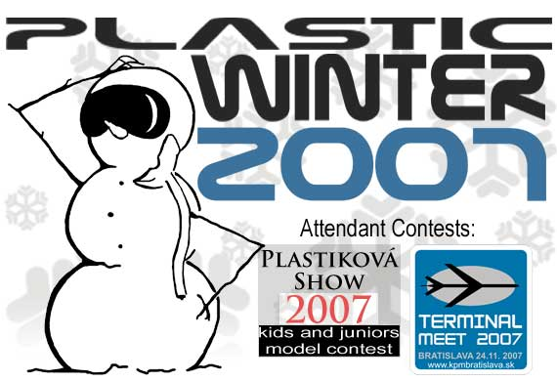
which will take place on Saturday
24th of November 2007
from 8:30 - 15:00
at Dom Kultúry RUŽINOV
(Courthouse Ruzinov)
Ružinovská 28, Bratislava
Contest categories:

Plastic Winter 2007
A - Aircraft
A1 - Aircraft smaller than 1/72 |  | A2 - Aircraft 1/72 - jets
A3 - Aircraft 1/72 - propelled |  | A4 - Aircraft 1/48 - jets
A5 - Aircraft 1/48 - propelled |  | A6 - Aircraft bigger than 1/48
A7 - Helicopters, all scales
B- Armor
B1 - Armor 1/72 on tracks |  | B2 - Armor 1/72 on wheels
B3 - Armor 1/35 on tracks |  | B4 - Armor 1/35 on wheels
B5 - Armor 1/48
C - Civilian vehicles
C1 - Civilian vehicles 1/24 and smaller |  | C2 - Civilian vehicles bigger than 1/24
D - Figures and busts
D1 - Figures,busts smaller than 90mm |  | D2 - Figures,busts bigger than 90mm
E - Dioramas
E1 - Dioramas smaller than 1/48 |  | E2 - Dioramas 1/48 and bigger
F- Ships
F1 - Ships, all scales
G- Other
G1 - Other
P- Paper models
P1 - paper models, all scales
Special Categories:
SP1 - Bratislavská "kosa" - models in winter camouflage, all types and scales
SP2 - You tow me!!! - aircraft models towed by vehicle, vehicle models towing aircraft
*it is allowed for models that already entered any standard category at previous years of Plastic Winter to enter Special Category
Special Trophies:
Magnet Press Trophy - Best of Show
KPMBA Woman Trophy - best model according to judgement of KPMBA women
"Polished Christmass ball" - for aircraft and vehicle model with the best glossy finish
Visitors Cup - best model according to visitors opinion

Plastiková Show 2007
Organized by: Klub plastikových modelárov Cyprián
younger scholars  (up to 10 years)  MZ1 - aircraft, jet  MZ2 - propelled aircraft and helicopters  MZ3 - Armor  MZ4 – Dioramas, figures, busts  MZ5 – civil vehicles  MZ6 - ships, Sci-fi, paper models | older scholars  (up to 14 years)  SZ1 - aircraft, jet  SZ2 - propelled aircraft and helicopters  SZ3 - Armor  SZ4 – Dioramas, figures, busts  SZ5 – civil vehicles  SZ6 - ships, Sci-fi, paper models | Juniors  (up to 18 years)  J1 - aircraft, jet  J2 - propelled aircraft and helicopters  J3 - Armor  J4 – Dioramas, figures, busts  J5 – civil vehicles  J6 - ships, Sci-fi, paper models
Special Trophies
Rescue Team Slovakia and portal zachranari.sk Trohpy - best rescue equipment
All Model Banská Bystrica Trophy
KOPRO Trophy

Exhibition and contest of airliner and civil aircraft models,
all scales.
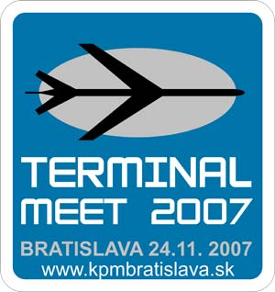
TERMINAL MEET Bratislava 2007 is supported by:
 |  | 

Terms and conditions:
Number of models from author entered in any desired category is not limited (in case of placing more than one model from one author in first three ranks in the category, only best ranked model will be awarded) . Evaluation will be carried out by committee established from organizing club members and will be based on best subjective attitude of committee members. In case that category will be occupied by less then six models, contest officials reserve the right to join or even cancel this category. Models built by organizing Club members will not be evaluated!
Models sellers stands, model bourse and attendant programme will be part of the event.
Contest schedule:
24.11.2007 (Saturday) 08:30 - 10:30 enrollment
11:00 - official opening
12:00 - 14:00 models evaluating
from 14:30 awards announcements
15:00 - 16:00 - estimated official end of Plastic Winter
Enrollment and entrance fee:
Entrance fee: FREE (voluntary)
Enrollment fee:
Adults: 30,-Sk
Junior: free
Contact and info: zima@kpmbratislava.sk

Plastic Winter main partners: | Partners:
 | 
 | 
 | 
Mediálny partner:

Location – Dom Kultúry Ružinov, Ružinovská 28, Bratislava
GPS: 48°9'25.24"N / 17°9'53.35"E
